**Title: Student Attendance Calculator**

**MINI PROJECT**

As a Field work for Course

Computer Programming (CSE 101)

**By**

|  |  |  |  |  |  |  |
| --- | --- | --- | --- | --- | --- | --- |
| Sr. No. | Registration No. | Name of Students | Roll No | Total Marks | Marks Obtained | Signature |
| 1. | 12218692 | SHREY GARG | RKOCCFA17 |  |  |  |



**Assistant Professor**

**Submitted To Mr. Kuldeep Kumar Kushwaha**

Lovely Professional University

Jalandhar, Punjab, India.

|  |  |
| --- | --- |
| **Delivered by:** | **Received by:** |
| Name of the Student: Shrey Garg  Reg. No: 12218692  Section: KOCCF  Roll Number: 17 | Name of the faculty: Mr. Kuldeep Kumar Kushwaha  UID: 17118 |

**ACKNOWLEDGEMENT**

I would like to express my sincere gratitude and appreciation to all those who have contributed to the successful completion of this project. First and foremost, I would like to thank my teacher Mr. Kuldeep Kumar Kushwaha, for providing me with valuable insights, guidance, and support throughout the project. Without her constant encouragement and assistance, this project would not have been possible. Their contributions were crucial to the success of this project. I am also thankful to my friends and family members for their support, understanding, and encouragement throughout this journey. Their love and support have been my source of inspiration and motivation. Finally, I would like to acknowledge the contribution of all those who have been a part of this project, directly or indirectly.

Thank you for your valuable input and support.

**ABOUT PROJECT**

**TITLE:**

Student Attendance Calculator Project in C Programming.

**Description:**

The Student Attendance Calculator is a C programming project that helps to track and calculate student attendance for a particular class. It allows the user to enter student information such as name, roll number, and class and mark the attendance for each student. The project also allows the user to view the attendance records of a particular student or the entire class for a particular day or a range of days.

**Purpose:**

The purpose of this project is to provide a user-friendly interface to track and manage student attendance. The project will help teachers to keep track of the attendance records of their students, which will enable them to make better decisions regarding the academic performance of their students.

**Main Features:**

1. User interface to add student information, mark attendance, and view attendance records

2. Data storage using arrays to store the student data and attendance records.

3. Functionality to mark the attendance of students.

4. Functionality to view attendance records of a particular student or the entire class.

5. Option to calculate the percentage of attendance for a student or the entire class.

6. Error handling mechanisms to handle unexpected user inputs and other possible errors.

**MODULE EXPLANATION**

**Login module: -**

This login module uses a while loop to allow the user three attempts to enter a valid username and password combination. The program prompts the user to enter their username and password and compares them to a predefined username and password. If the login is successful, the program prints a message indicating that the login was successful. If the login fails, the program prints an error message and increments the login Attempt variable. If the user exceeds the maximum number of login attempts, the program exits.

**Insert module: -**

We define a structure called student that contains the name, ID, and age of a student. We also define an array of student structures called students, which has a maximum capacity of MAX_STUDENTS. We also define a variable num_students to keep track of the number of students currently in the students array.

**Display module: -**

The display_all_students function iterates over the student’s array and prints the name, ID, and age of each student to the console.

In the main function, we add some test data to the students array and then call the display_all_students function to display all the students.

**Search module: -**

In this program, we define a search Info function that takes in a two-dimensional character array representing some data, the number of entries in the array, and a search string as parameters. The function searches the data for any entry containing the search string and returns the index of the first matching entry, or -1 if no match is found. We then call this function from the main function to search for a specific name in the data array and display the matching record if found.

**Delete/ modify module: -**

In this program, the delete Or Modify function takes in the array, its size, the index of the element to delete/modify, and a choice variable that indicates whether to delete or modify the element. The function checks if the index is valid and then performs the appropriate action based on the choice variable.

**DFD (DATA FLOW DIAGRAM)**

**LEVEL 0**

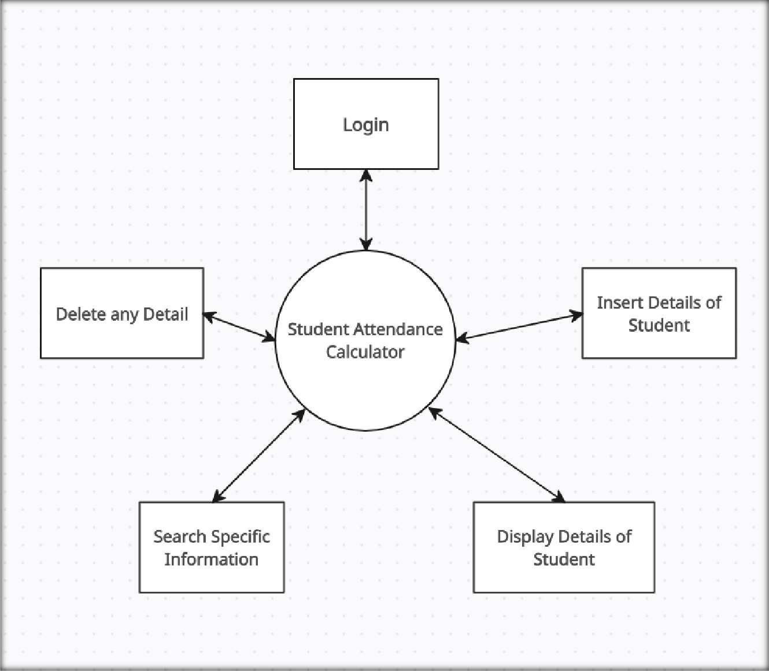**SOURCE CODE**

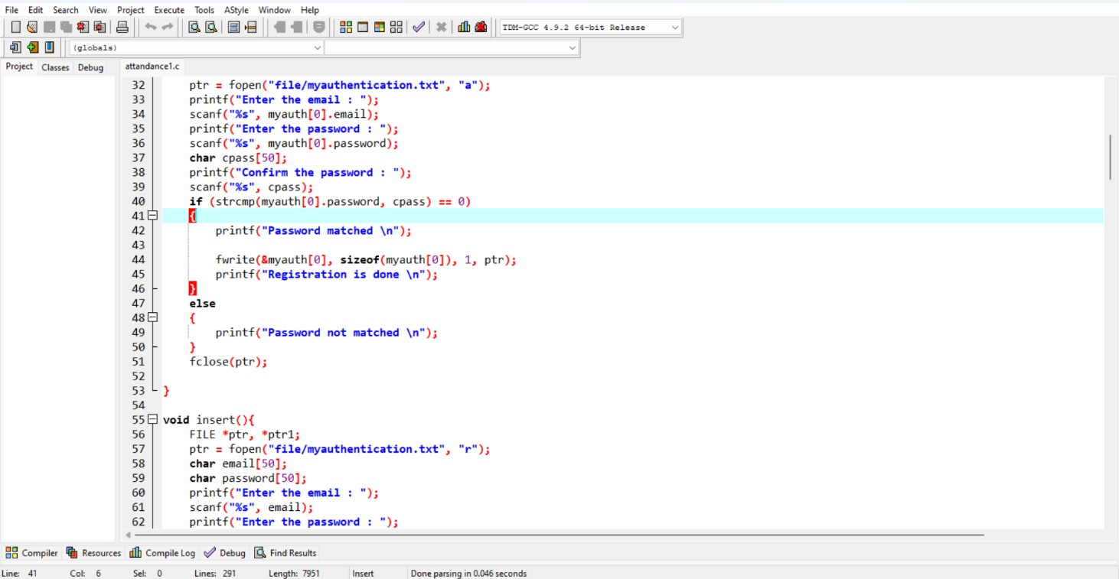

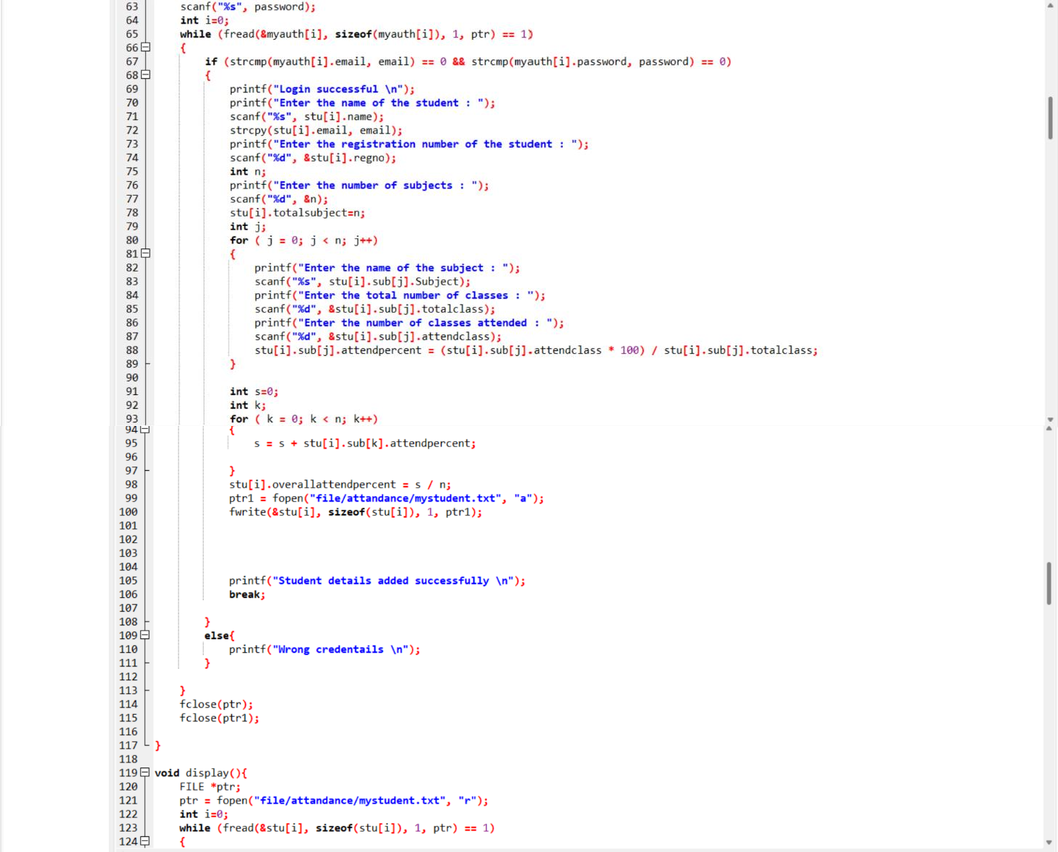

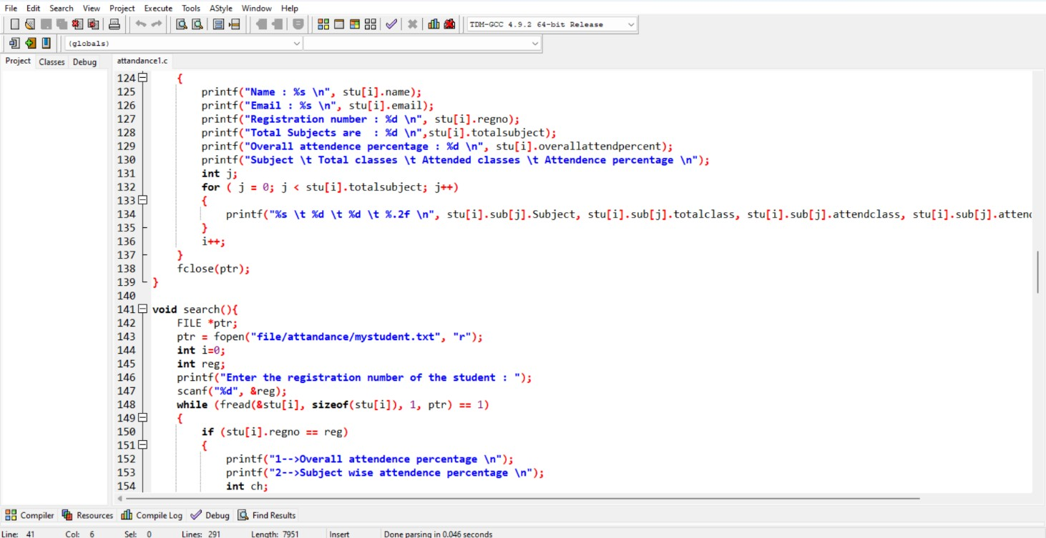

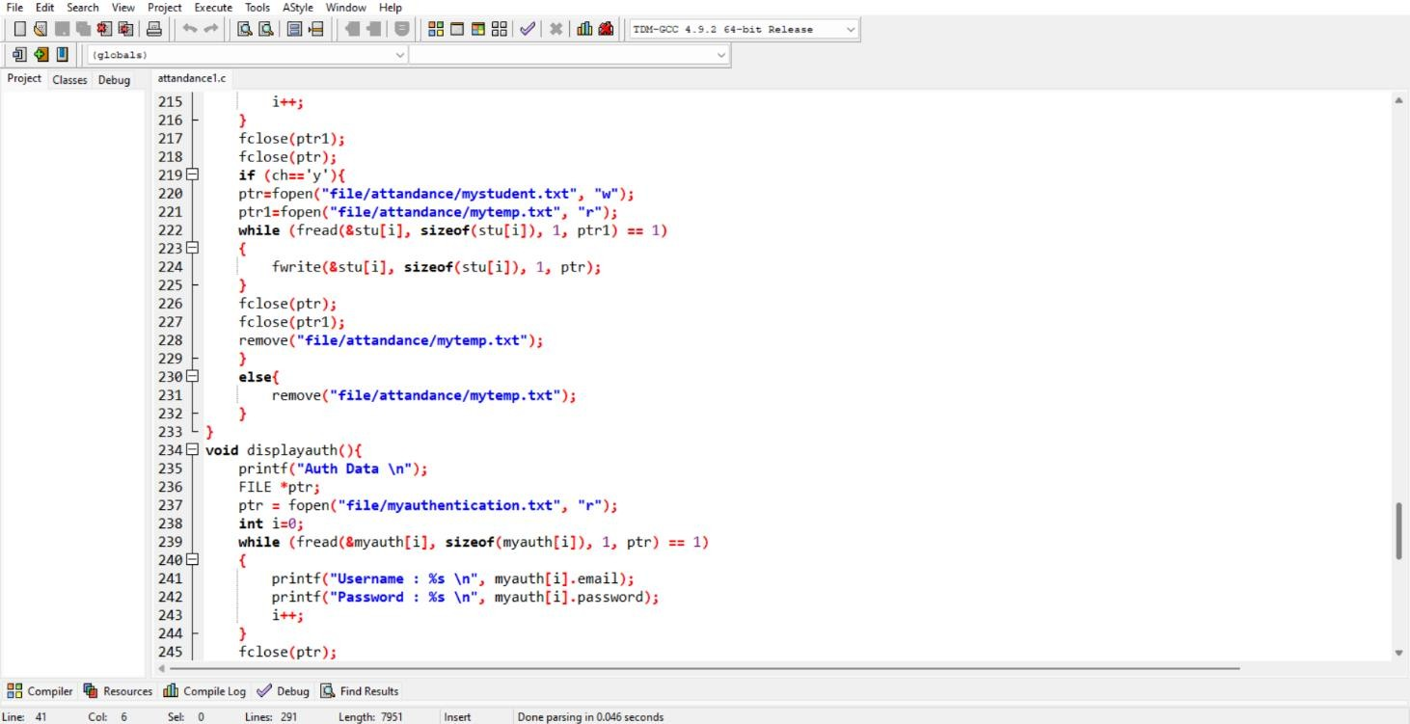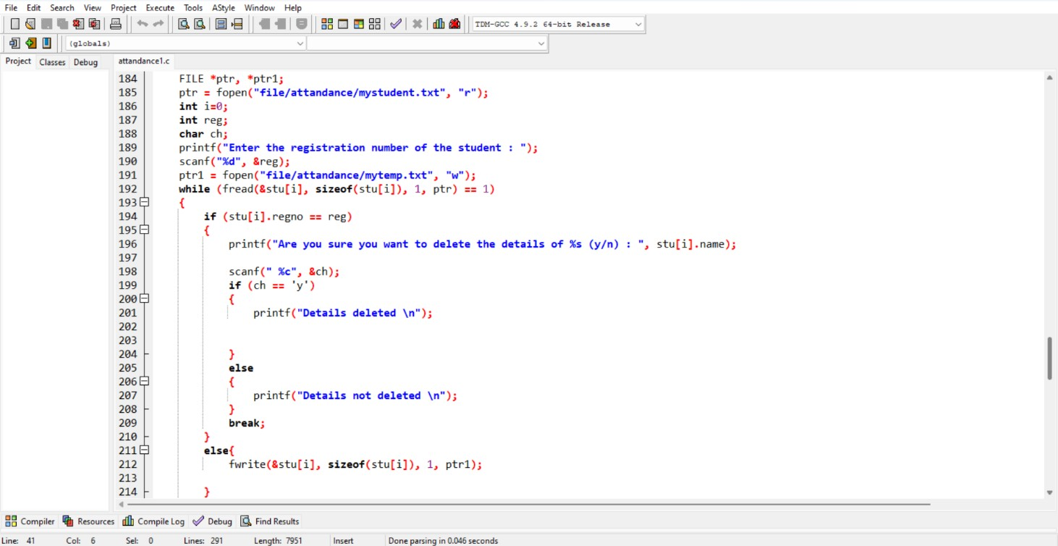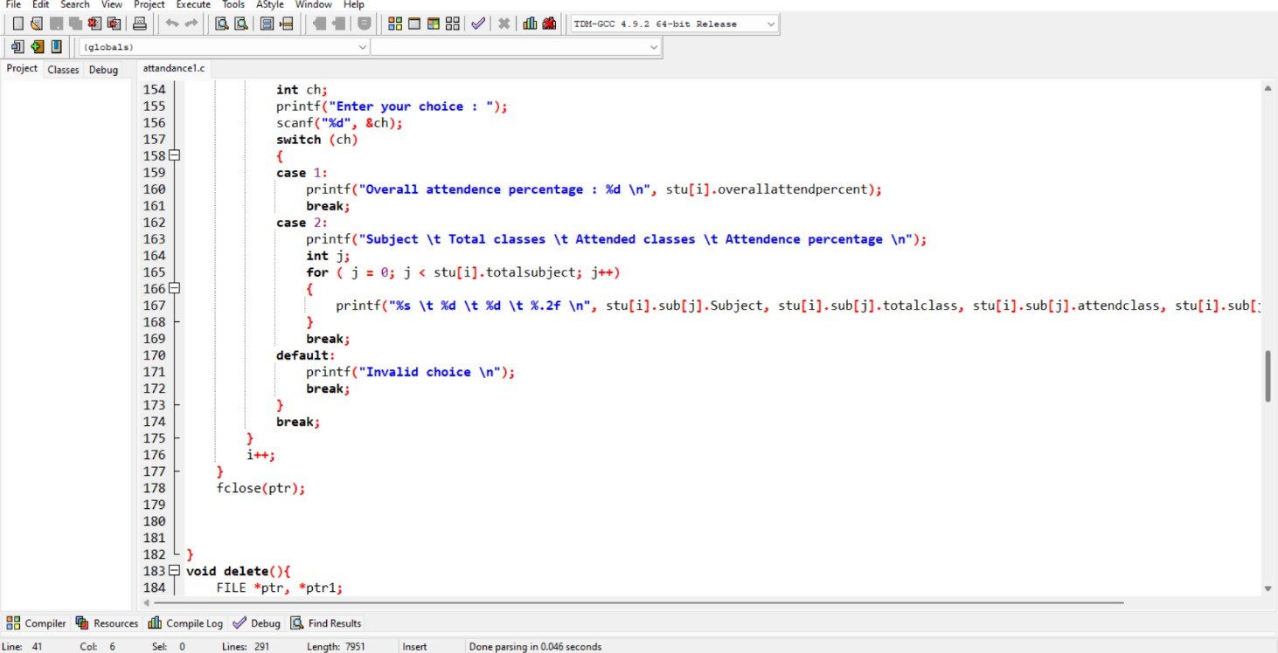

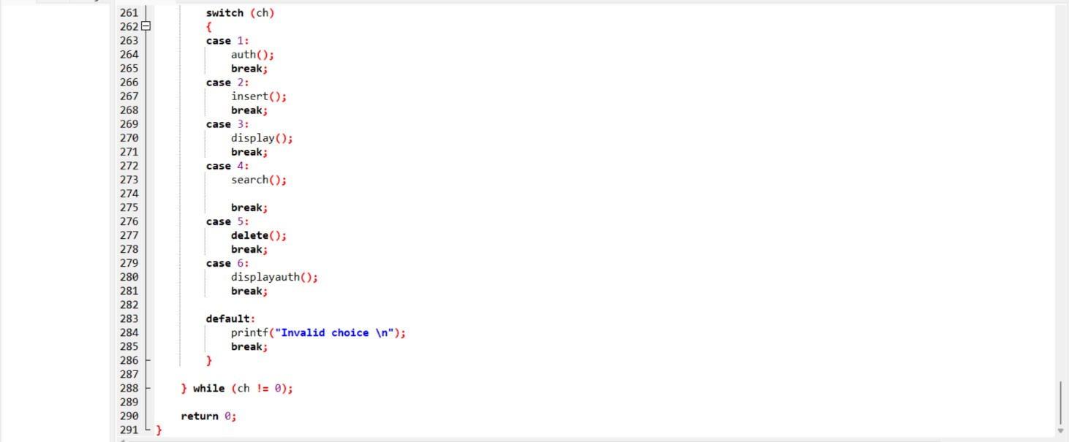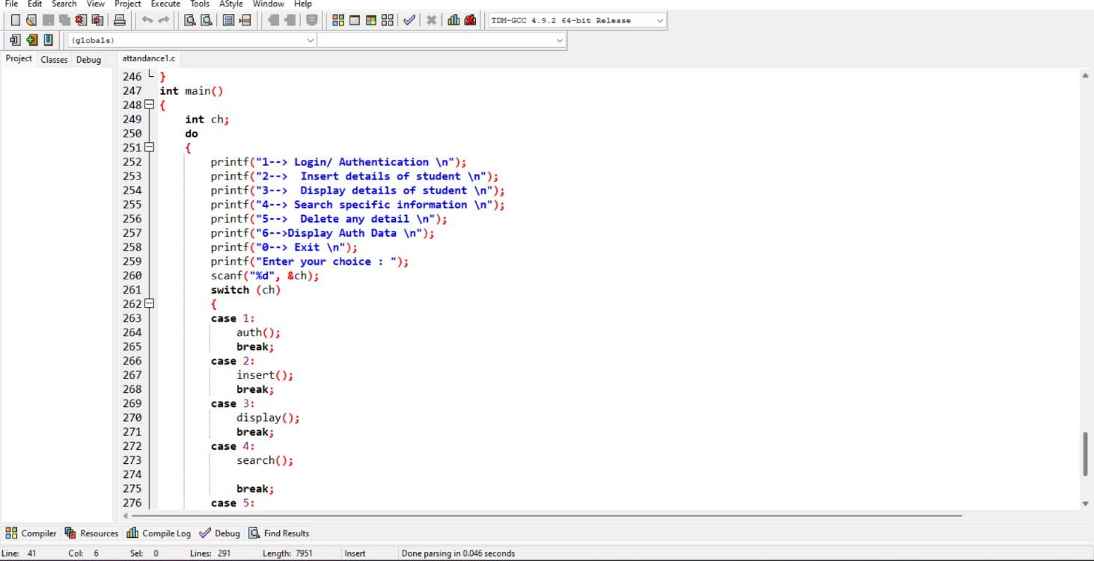

**OUTPUT SNAPSHOTS**

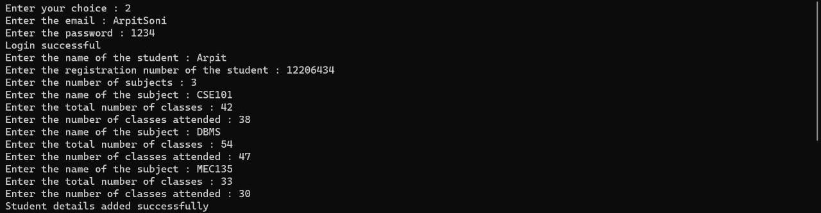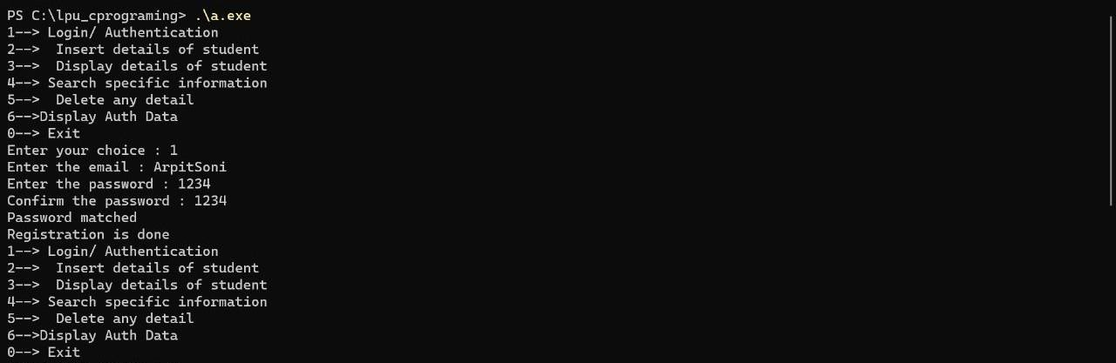

**MODULE 2 IS EXECUTED**

**MODULE 1 IS EXECUTED**

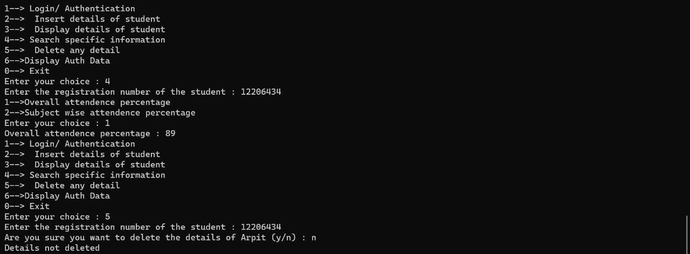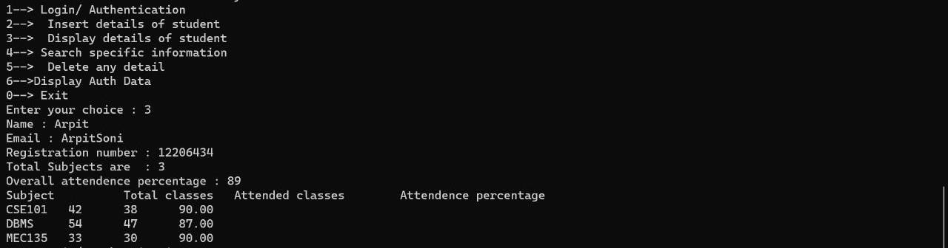

**MODULE 4,5,6 ARE EXECUTED**

**MODULE 3 IS EXECUTED**

**THE END**